Monolithic vs. Microservices Architecture
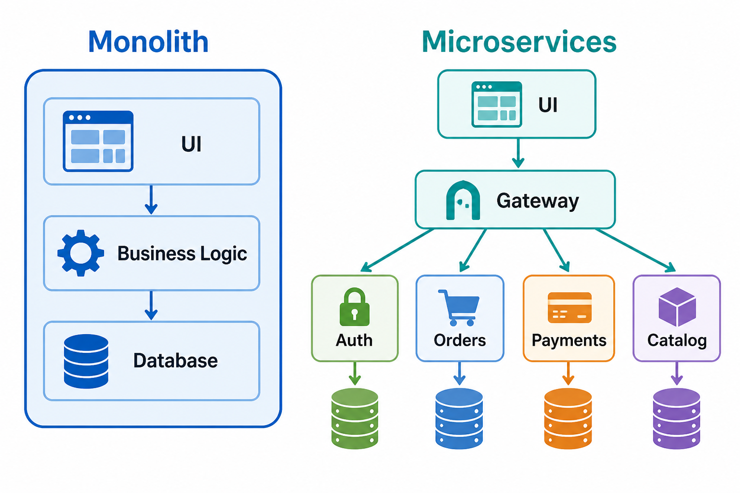

The short answer
For a small or new project, start with a modular monolith: one application, clearly separated modules. It is usually faster, cheaper, and simpler.
Use microservices when you have real reasons—many autonomous teams, independently scaling parts, strict isolation/security needs, or frequent independent deployments. Microservices are not automatically “more modern” or better.

1. What is a monolithic architecture?
A monolith is one application deployed as one unit. It may contain features such as login, orders, payments, and notifications, but they run together and commonly use one database.
Example: an online store may have one codebase and one deployment that manages product browsing, carts, checkout, and user accounts.

Advantages
- Simple to build, run, test, and debug at the beginning.
- Usually cheaper infrastructure: fewer servers, network calls, monitoring tools, and deployment pipelines.
- Fast communication inside the application; modules call each other directly rather than over a network.
- Easier transactions: for example, create an order and charge a payment in one database transaction.
- A cohesive team can work quickly because everyone understands one system.

Disadvantages
- As the application and team grow, the codebase can become tightly coupled and difficult to change safely.
- Usually deployed as one unit: a small change may require releasing the whole application.
- Scaling is less targeted: if only image processing needs more capacity, the whole application may be scaled.
- A bad deployment or major failure can affect the whole application.
- Many teams working in the same codebase can slow each other down.

2. What is microservices architecture?
Microservices split a product into small, independently deployed services. Each service owns a focused business capability—for example, catalog, payments, orders, or authentication—and communicates with other services through APIs or messages.
Example: in a ride-sharing app, trip matching, payments, driver management, maps, and notifications can be separate services.

Advantages
- Services can be deployed independently.
- Each service can scale independently. For example, the catalog service may need more capacity during a sale, while payments does not.
- Failures can be isolated; a recommendation service failing does not necessarily stop checkout.
- Clear ownership is possible: one team owns payments, another owns orders.
- Different services may use the most suitable technology or database.
- Useful for large organizations where teams must work independently.
Uber publicly describes its microservice architecture as supporting independent deployment, ownership, reliability, and autonomous teams—but also describes the operational complexity that came with thousands of services. Uber Engineering

Disadvantages
- Much harder to design and operate.
- Network calls are slower and less reliable than in-process calls.
- Debugging one customer request may require tracing across many services.
- Testing becomes harder because services must work together correctly.
- Data consistency is more difficult: an order service and payment service may not share one transaction.
- Requires mature practices: automated deployment, monitoring, logs, tracing, retries, API versioning, security, and on-call support.
- More infrastructure and people usually means higher cost.

3. Which is simpler and which is harder?
Question | Usually simpler
Building the first version | Monolith
Local development and debugging | Monolith
Testing a complete user flow | Monolith
Operating infrastructure | Monolith
Independent team releases at large scale | Microservices
Scaling one expensive feature only | Microservices
Isolating highly sensitive or high-risk functions | Microservices
So: a monolith is simpler at first; microservices are harder from day one. Microservices can become worthwhile when organizational and scaling needs become large enough.

4. When should you use each?
Situation | Better starting choice
Small project, MVP, student project, startup | Modular monolith
One cohesive team | Modular monolith
Product requirements changing quickly | Modular monolith
Limited DevOps or cloud experience | Modular monolith
Many independent teams working on separate domains | Microservices
One feature has very different scaling needs | Microservices for that feature
Strong security/compliance isolation, such as payment vaulting | Separate service may help
Frequent releases where teams must not wait for each other | Microservices

If the project is small
I would prefer a modular monolith. Keep modules such as users, orders, catalog, and payments separate in the codebase, with clear interfaces. This keeps the system easy to change now and makes future extraction possible.

If the project is large
Do not automatically choose “all microservices.” Prefer a modular monolith plus a few carefully chosen services. Extract only the parts that genuinely need independent scaling, security isolation, or separate ownership.

If the team is cohesive
A cohesive team is a strong argument for a modular monolith, even for a fairly large product. Good collaboration reduces the main organizational benefit of microservices. Choose microservices later only if team autonomy, scaling, or reliability boundaries require them.

5. Which is used most of the time?
There is no reliable global count, because companies often use a mixture. In practice:
- New products and small-to-medium teams commonly begin with a monolith.
- Large technology organizations commonly use many services.
- The most common sensible long-term answer is often a hybrid: a modular monolith for the core product, plus services around clear boundaries.

6. Real successful examples
- Shopify has publicly described its core system as one of the world’s largest Rails monoliths and has invested in making it a modular monolith. It also extracts specific functions, such as storefront rendering, when independent scaling is valuable. Shopify Engineering
- Uber started with a monolith and moved toward microservices as its product, traffic, and engineering organization grew. It later had to reduce the complexity created by a very large service estate. Uber’s architecture discussion
- Prime Video reworked one audio/video monitoring workload from a distributed, serverless design into a monolithic application, reporting over 90% lower infrastructure cost. This was not “all of Prime Video becoming one monolith”; it was a targeted architecture decision for one workload. Prime Video Tech case study

7. Why companies move from monolith to microservices
They usually move because the monolith has grown into a real bottleneck:
- Too many developers must coordinate one release.
- Different areas need independent scaling.
- A failure in one feature threatens the whole product.
- Teams need clearer ownership and faster independent delivery.
- Security-sensitive work needs stronger isolation.
The right approach is usually gradual extraction, not a full rewrite. For example, extract notifications, search, reporting, or media processing first.

8. Why companies move from microservices back toward a monolith
They do this when services were split too early or too finely:
- Too many network calls create latency and cost.
- Features require changing several services at once.
- The “independent” services actually have shared data and must deploy together. This is called a distributed monolith.
- Debugging, monitoring, and testing cost too much.
- The team is too small to own all the operational work.
- A workflow needs strong consistency and is simpler in one process.
This is not a failure. It is architecture learning: keep distribution only where it solves a real problem.

9. Best practical recommendation
Start with this rule:
Build a modular monolith first. Extract a service only when you can clearly name the problem it solves.
A good first structure might be:
One application → modules for Users, Catalog, Orders, Payments, Notifications → one database
Later, you might extract:
One application + separate Search service + separate Media-processing service + separate Payment-vault service
That path gives you simplicity first, while preserving a safe route to microservices when the evidence supports it.

